WEEK 2 — EXPLORATORY DATA ANALYSIS & VISUALIZATION
Hotel Booking Cancellation Analysis
Project Documentation | Cleaned Dataset: 87,396 records × 34 variables
1. Purpose of Week 2
The second week of the project focused on Exploratory Data Analysis (EDA). The aim was to understand the structure of the cleaned hotel-booking dataset, identify important cancellation patterns, compare customer and booking characteristics, and visually examine relationships that may be useful for prediction.
2. EDA Approach
• Calculated the overall cancellation rate and the distribution of cancelled versus non-cancelled bookings.
• Compared cancellation rates across hotel type, market segment, customer type, and deposit type.
• Compared average lead time and Average Daily Rate (ADR) for cancelled and non-cancelled bookings.
• Used bar charts, a histogram, a monthly trend chart, and a correlation heatmap to communicate the results.
• Used correlation analysis to identify numerical variables that could be useful as predictors in the later classification model.
3. Initial Dataset Findings
Measure | Result | Interpretation
Total observations | 87,396 | Records available after cleaning
Total variables | 34 | Booking, customer, pricing and cancellation attributes
Cancelled bookings | 24,025 | 27.49% of all records
Non-cancelled bookings | 63,371 | 72.51% of all records
Mean lead time — cancelled | 105.72 days | Cancelled bookings were made farther in advance on average
Mean lead time — not cancelled | 70.10 days | Non-cancelled bookings had shorter average lead times
4. Booking and Hotel-Level Visualizations
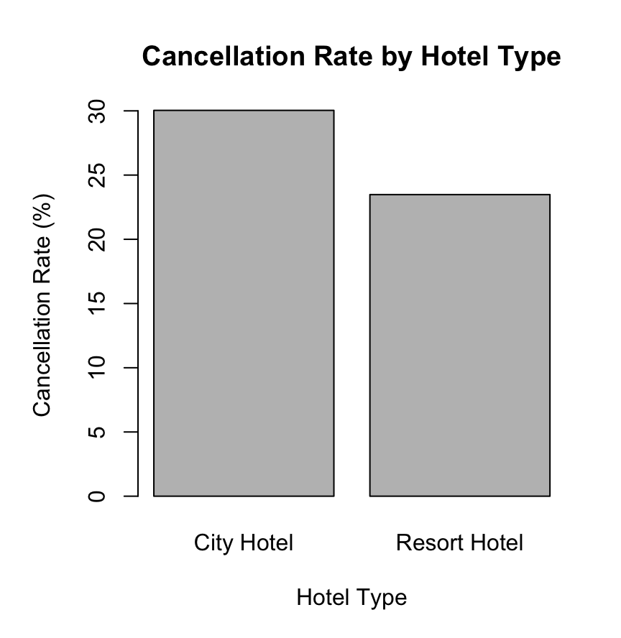  Cancellation Rate by Hotel Type  This comparison examines whether cancellation behaviour differs between City Hotel and Resort Hotel. The result provides an early indication that hotel category can be relevant when explaining cancellation risk. | 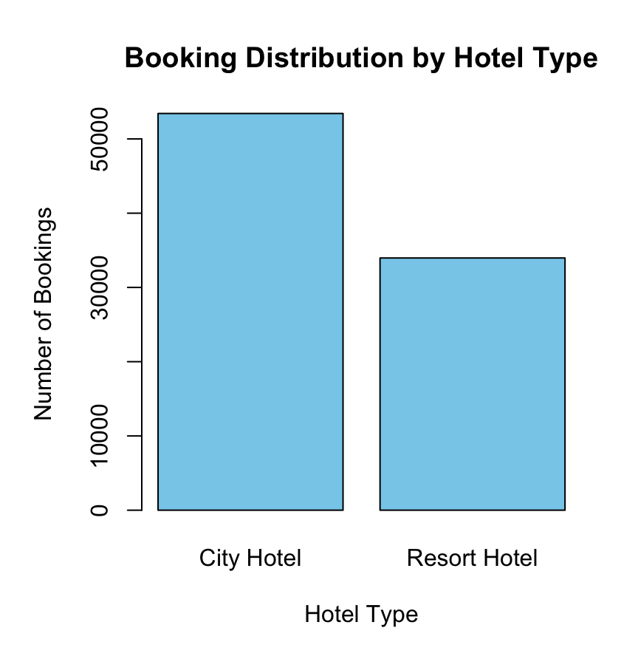  Booking Distribution by Hotel Type  This chart shows the volume of bookings received by each hotel category. It should be considered together with the cancellation-rate chart because a category with more bookings can naturally contribute more total cancellations.
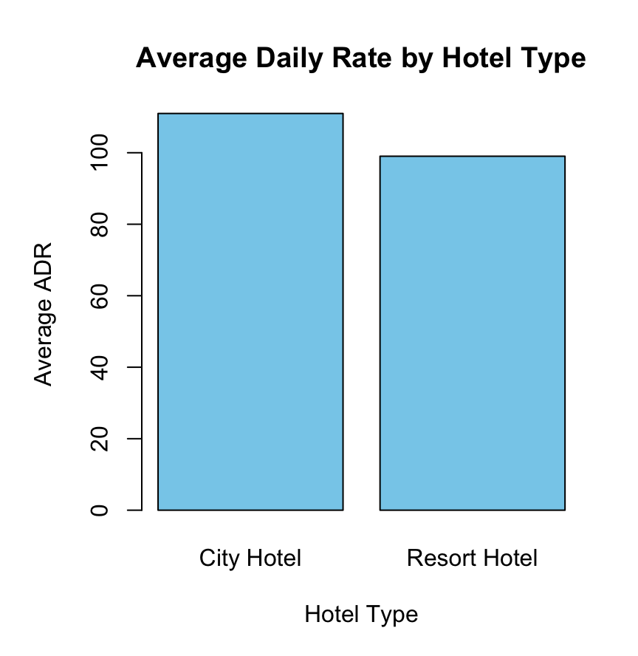  Average Daily Rate by Hotel Type  ADR represents the average daily room price. City Hotel has a higher average ADR than Resort Hotel in this dataset, indicating a difference in the pricing profile of the two hotel categories. | 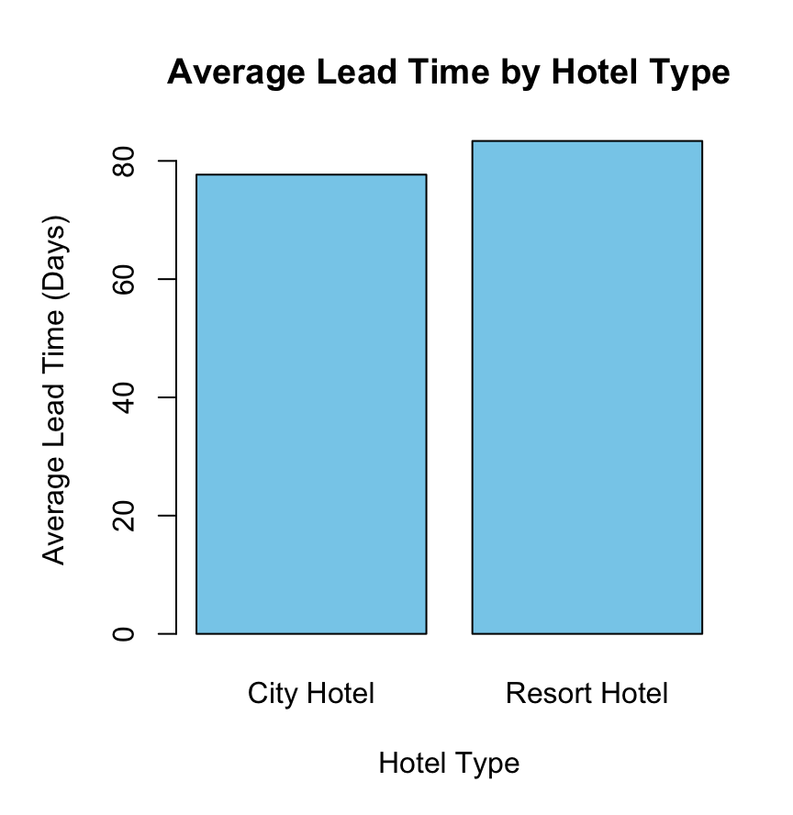  Average Lead Time by Hotel Type  Lead time measures the number of days between booking and arrival. Comparing the averages helps identify differences in advance-booking behaviour between hotel types.
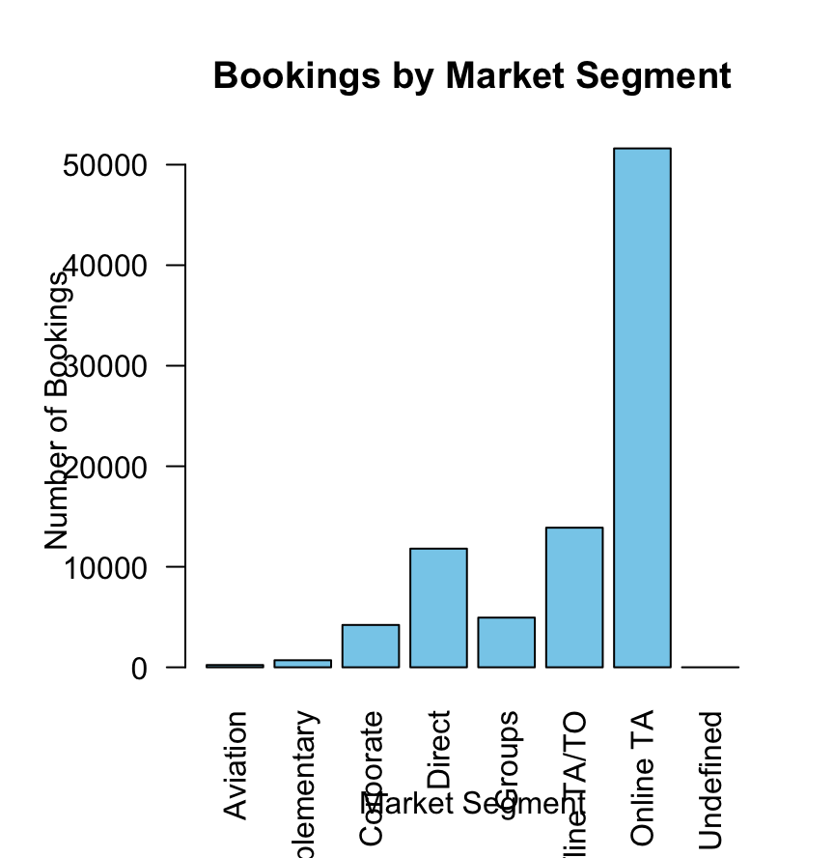
Bookings by Market Segment
Market segment describes the booking channel or customer acquisition category. The distribution helps identify the most important booking channels and provides context for later cancellation-rate comparisons.

WEEK 2 — DETAILED FINDINGS
5. Customer and Cancellation Analysis
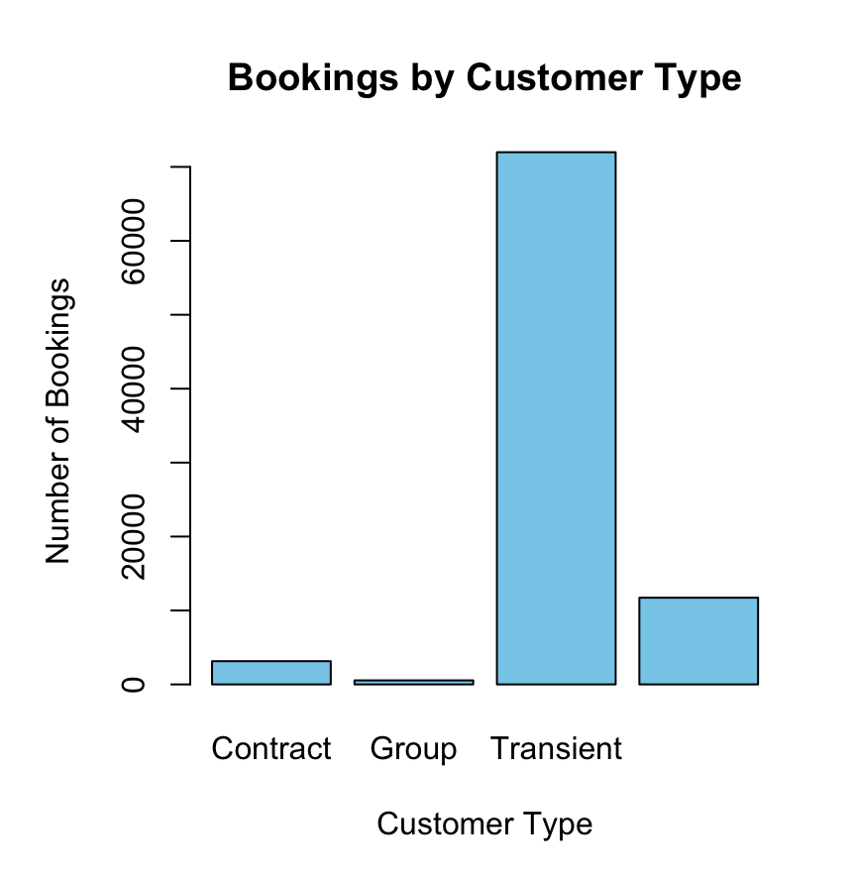  Bookings by Customer Type  The chart compares Contract, Group, Transient, and Transient-Party customers. Transient bookings form the dominant category, which is important because their behaviour can strongly influence overall cancellation patterns. | 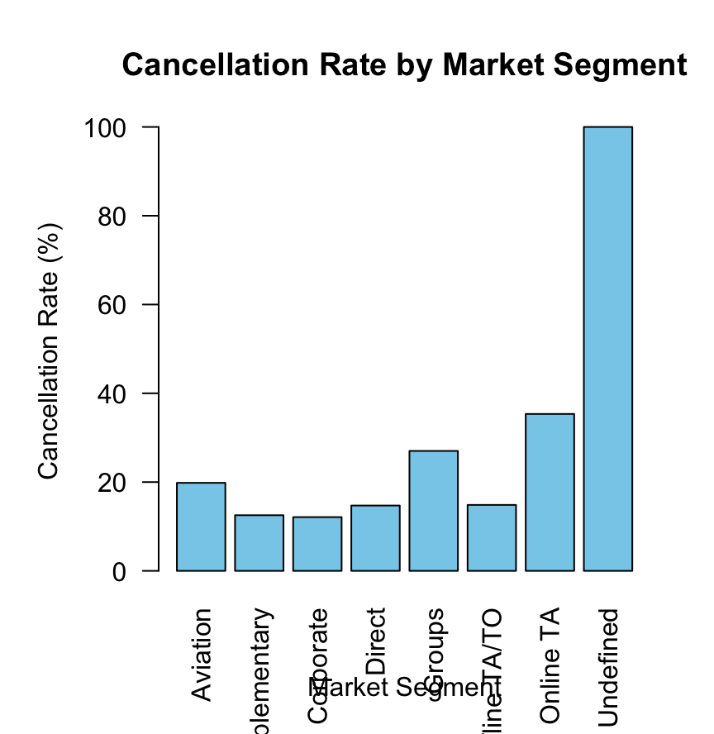  Cancellation Rate by Market Segment  Cancellation rates vary substantially across market segments. Online TA has a relatively high cancellation rate, whereas Corporate and Complementary bookings show lower rates. The Undefined category reaches 100%, so it should be interpreted carefully because the category may contain very few or unusual records.
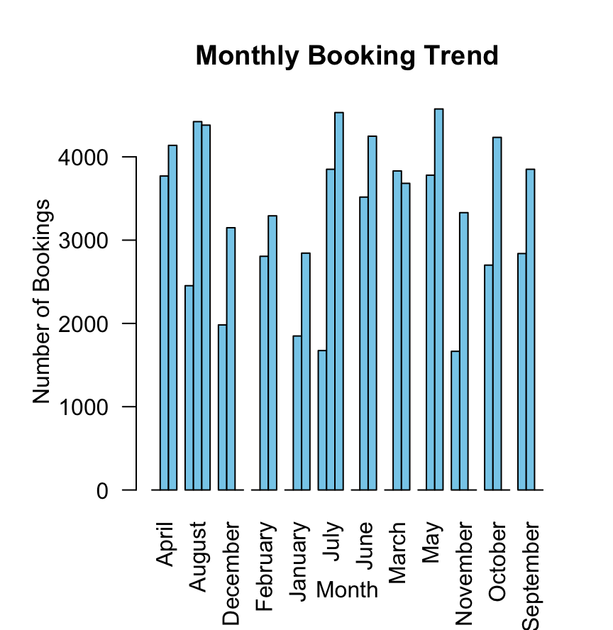  Monthly Booking Trend  The monthly trend compares booking volumes across arrival years and months. This helps reveal seasonality and changes in demand over time, which may be useful for operational planning. | 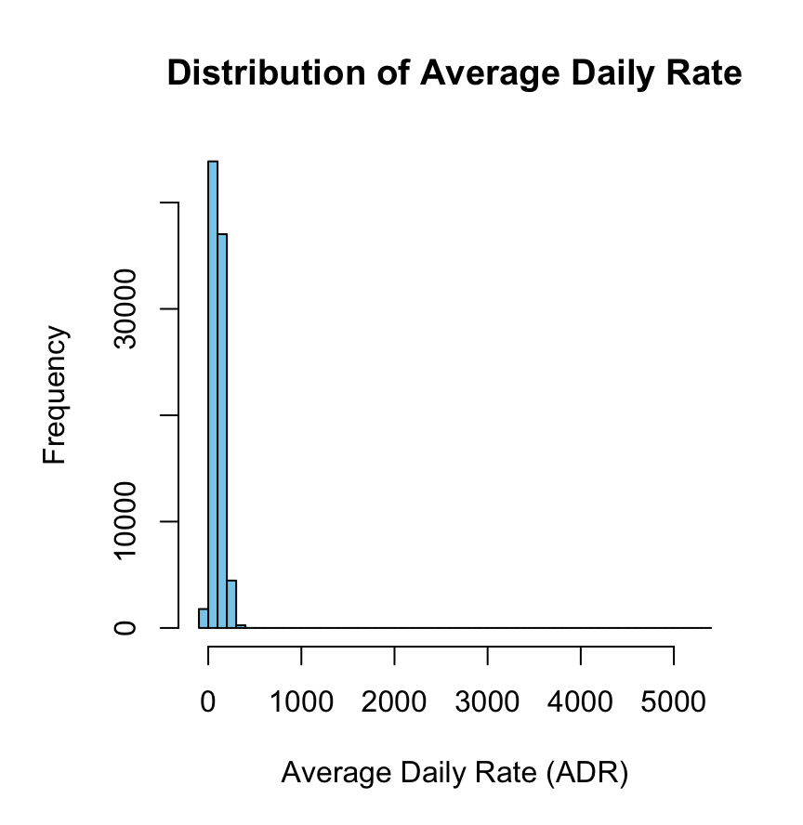  Distribution of Average Daily Rate  The histogram describes the spread of ADR values. Most observations are concentrated within the lower-to-middle price range, while higher ADR values form a smaller tail. This distribution is useful when checking pricing behaviour and potential outliers.
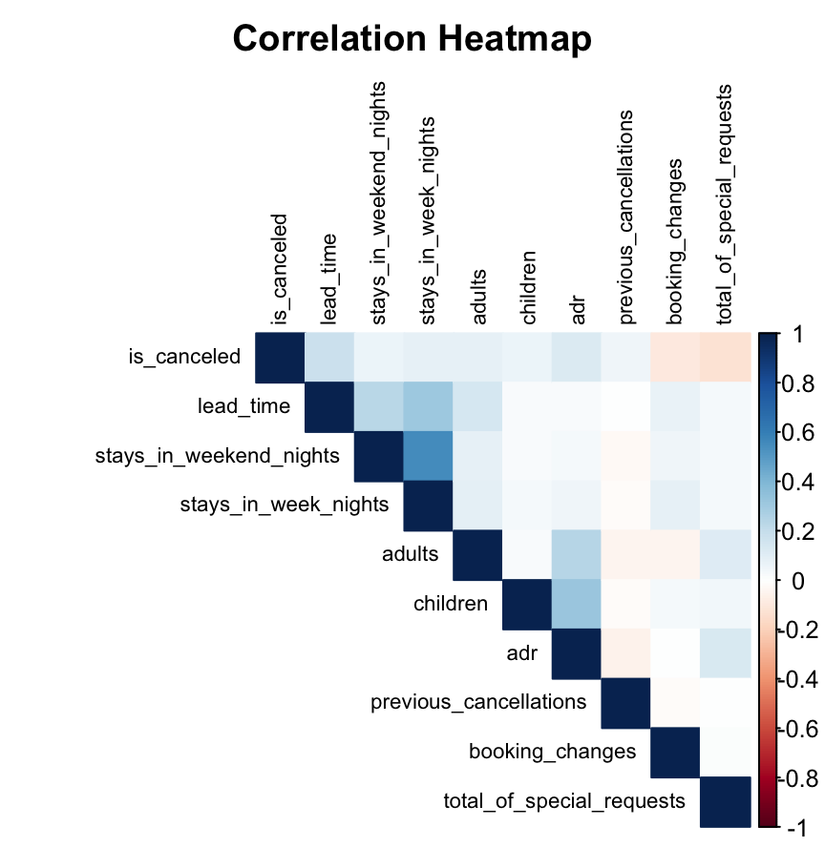
Correlation Heatmap
The heatmap summarizes linear relationships between selected numerical variables. Lead time has the strongest positive correlation with cancellation among the listed variables (about 0.185), while total special requests has a negative correlation (about -0.121).

WEEK 2 — STATISTICAL INTERPRETATION & CONCLUSION
6. Statistical Comparison of Lead Time
A Welch two-sample t-test was used to compare lead time between cancelled and non-cancelled bookings. The mean lead time was 105.72 days for cancelled bookings and 70.10 days for non-cancelled bookings. The estimated mean difference was approximately 35.62 days. The test produced t = 52.719 with p < 2.2 × 10⁻¹⁶, indicating a statistically significant difference between the two groups.
7. Statistical Comparison of ADR
ADR was also compared between cancelled and non-cancelled bookings. Cancelled bookings had a mean ADR of 117.77, while non-cancelled bookings had a mean ADR of 102.00. The Welch t-test returned t = 35.05 with p < 2.2 × 10⁻¹⁶, providing strong evidence that the average ADR differs between the two groups.
8. Correlation Findings
Variable vs. is_canceled | Correlation
lead_time | 0.1848
adr | 0.1280
previous_cancellations | 0.0515
booking_changes | -0.0936
total_of_special_requests | -0.1205
stays_in_weekend_nights | 0.0602
stays_in_week_nights | 0.0829
adults | 0.0818
children | 0.0674
9. Key Insights
• The overall cancellation rate is 27.49%, meaning slightly more than one in four bookings in the cleaned dataset was cancelled.
• Cancellation rates vary by hotel type, market segment, customer type, and deposit type, showing that booking context matters.
• Cancelled bookings have substantially higher average lead time than non-cancelled bookings.
• Cancelled bookings also have a higher average ADR, suggesting that pricing may contribute useful information to cancellation prediction.
• Lead time has the strongest positive correlation with cancellation among the selected numerical variables, although the correlation is moderate rather than strong.
• Special requests and booking changes have negative correlations with cancellation, suggesting that more engaged bookings may be less likely to cancel.
10. Week 2 Conclusion
The EDA established the major patterns in the hotel-booking data and identified variables that may help distinguish cancelled from non-cancelled reservations. The statistical tests confirmed meaningful differences in lead time and ADR, while the correlation analysis provided an initial view of numerical relationships. These findings were used to support feature selection and model development in the subsequent predictive-modelling stage.
Tools Used
R, tidyverse, ggplot2, base R aggregation functions, statistical t-tests, and correlation analysis.

